

OBJECT ORIENTED PROGRAMMING

SUBMITTED BY:

**Members:**

Shahzeb Asghar

HOSPITAL MANAGEMENT SYSTEM

1 4.25.2022

**Prototype of our Hospital Management System can be accessed live at** [**http://hms.wpprohelper.com/**](http://hms.wpprohelper.com/)

**Software Used for Making Prototype:**



# Modules List:

Doctor Details

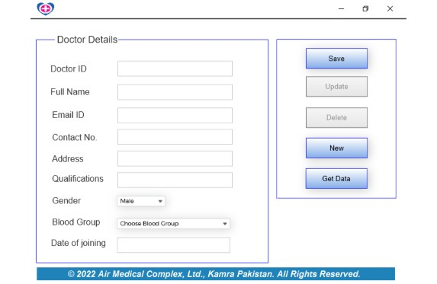

Patient Details

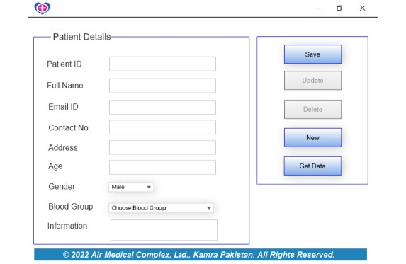

Patient Admit Info

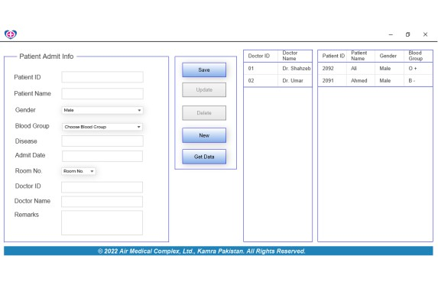

Patient Info

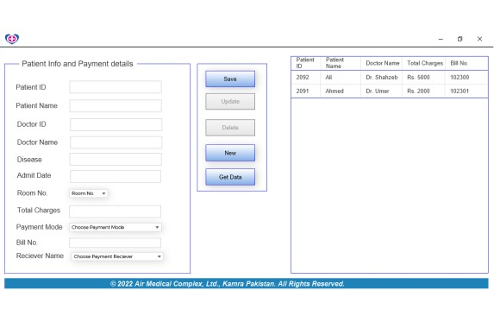

Service Info

